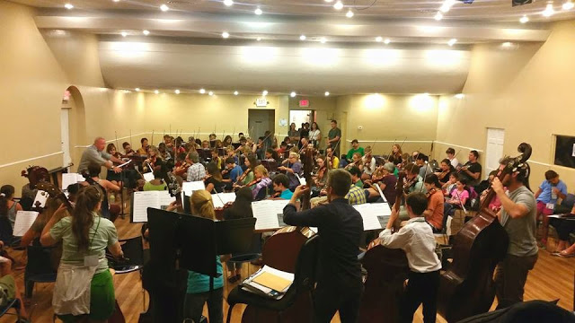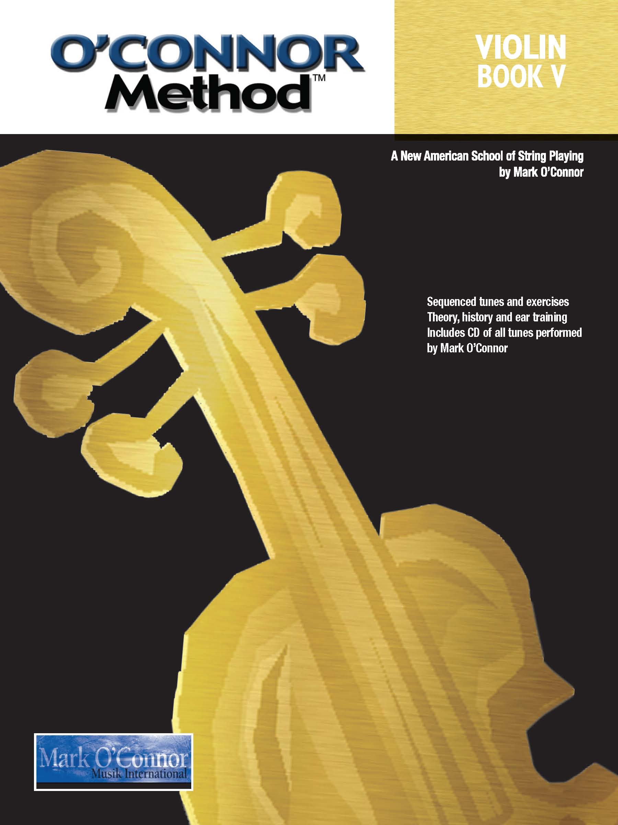

O’Connor Method Camp NYC

**Available to String**

**Players of All Ages!**

Find out more about the

*O’Connor Method* at

**www.oconnormethod.com**

Take the **“A” Camp** for students in Books III & IV of *O’Connor Method* (Intermediate to Advanced) - $550

Take the **“B” Camp** for students in Books I & II of *O’Connor Method* (Beginner) - $550

Take the **“M” Half-Day Camp** for young students ages 4-7 (Beginner) - $450

**Teacher Training** for teachers and music education students in *O’Connor Method* Books I & II or

Books III & IV - $550

Register at **www.oconnormethodcampnyc.com**



Jul. 31 – Aug. 4, 2017

Orientation Jul. 30

***O’Connor Method Camp NYC*** is a music instruction camp for violin, viola, cello, double bass, and orchestra based on the *O’Connor Method.* This camp uses American music, creativity, cultural diversity, and improvisation to improve learning for both children and adults who want to take string lessons while enjoying and exceling at music.

*“Collectively we are changing*

*the world one fiddle at a time.”*

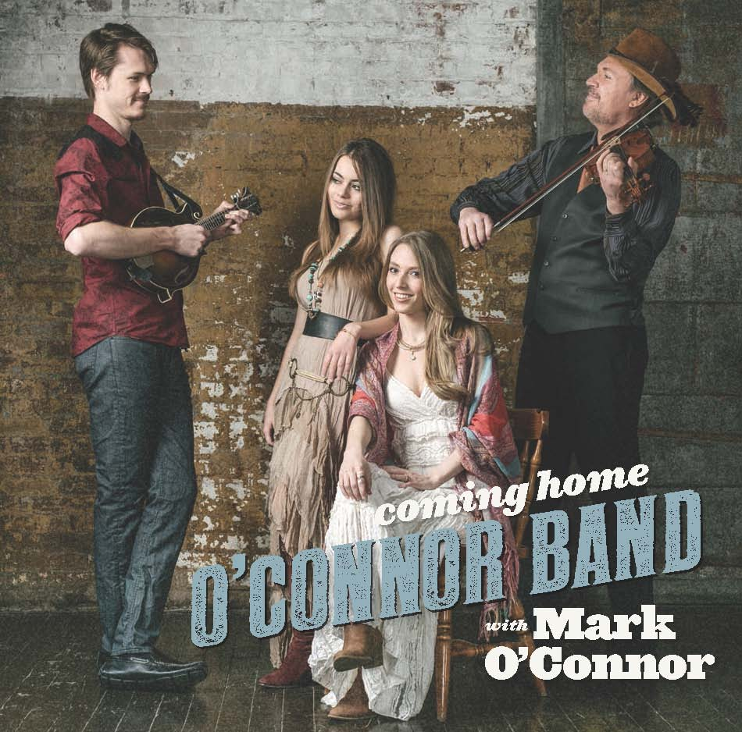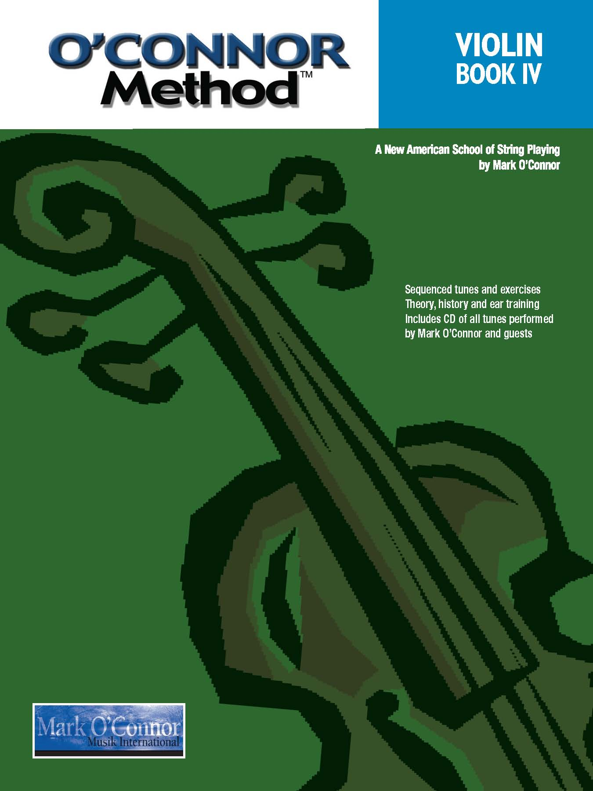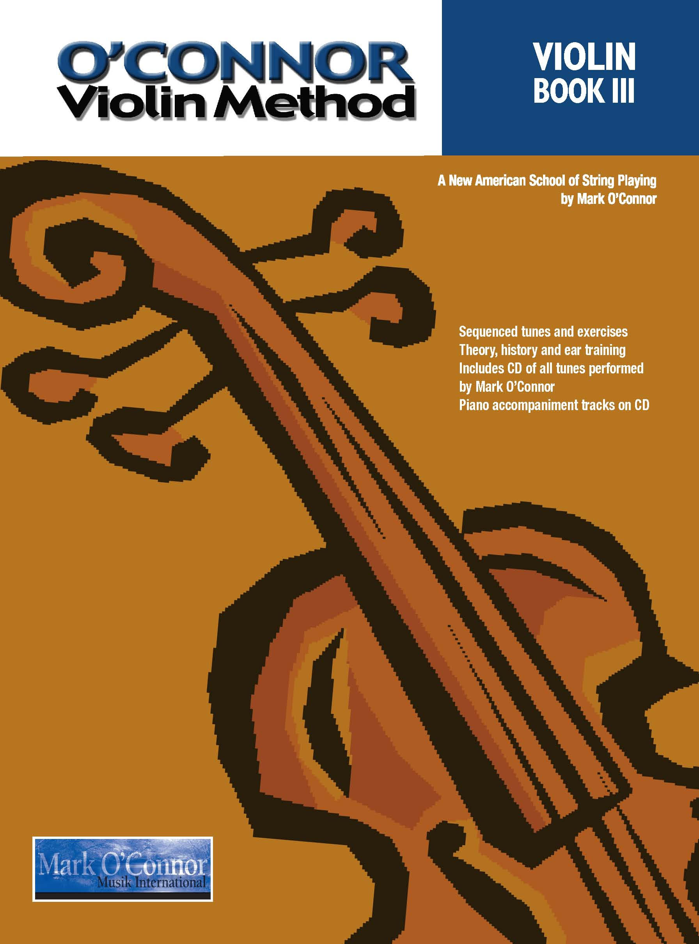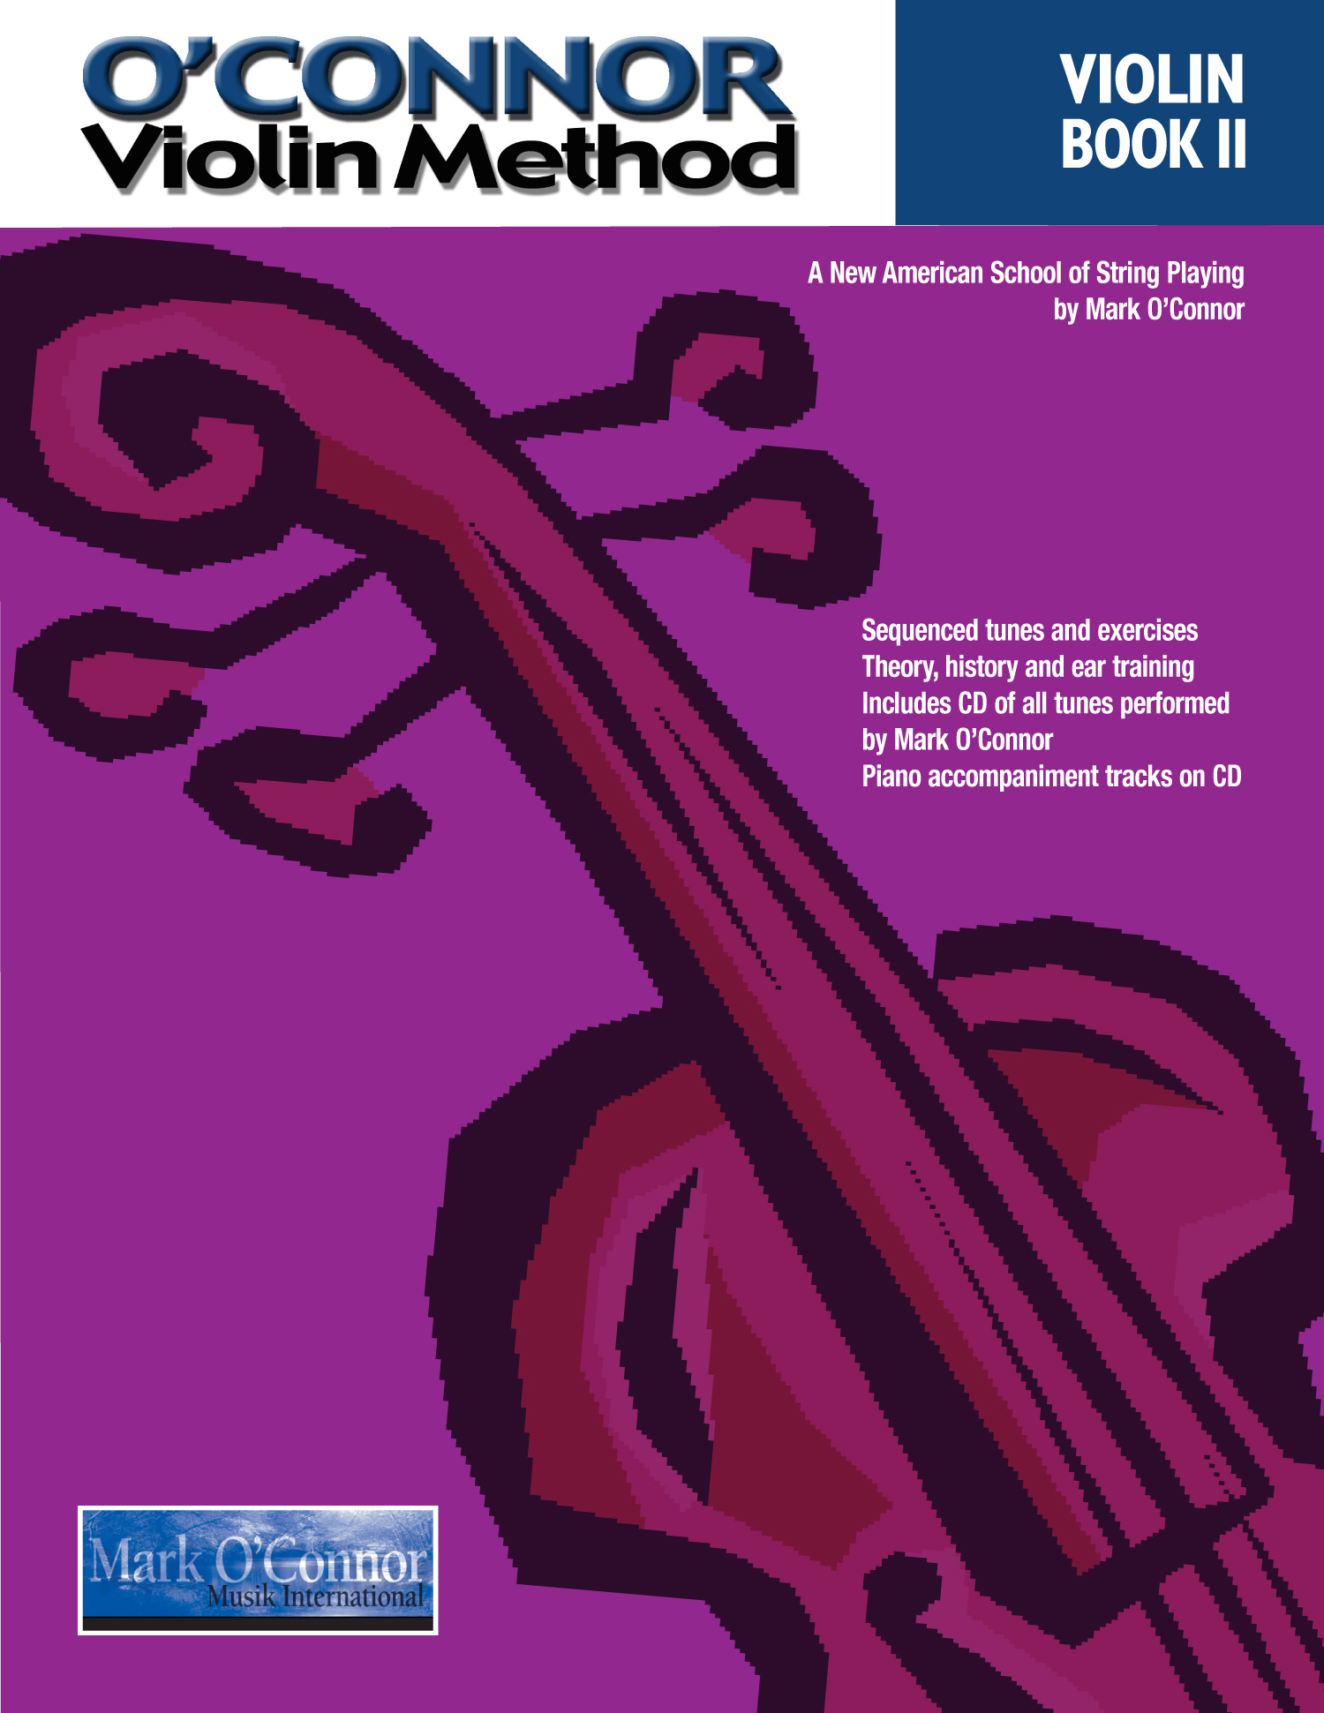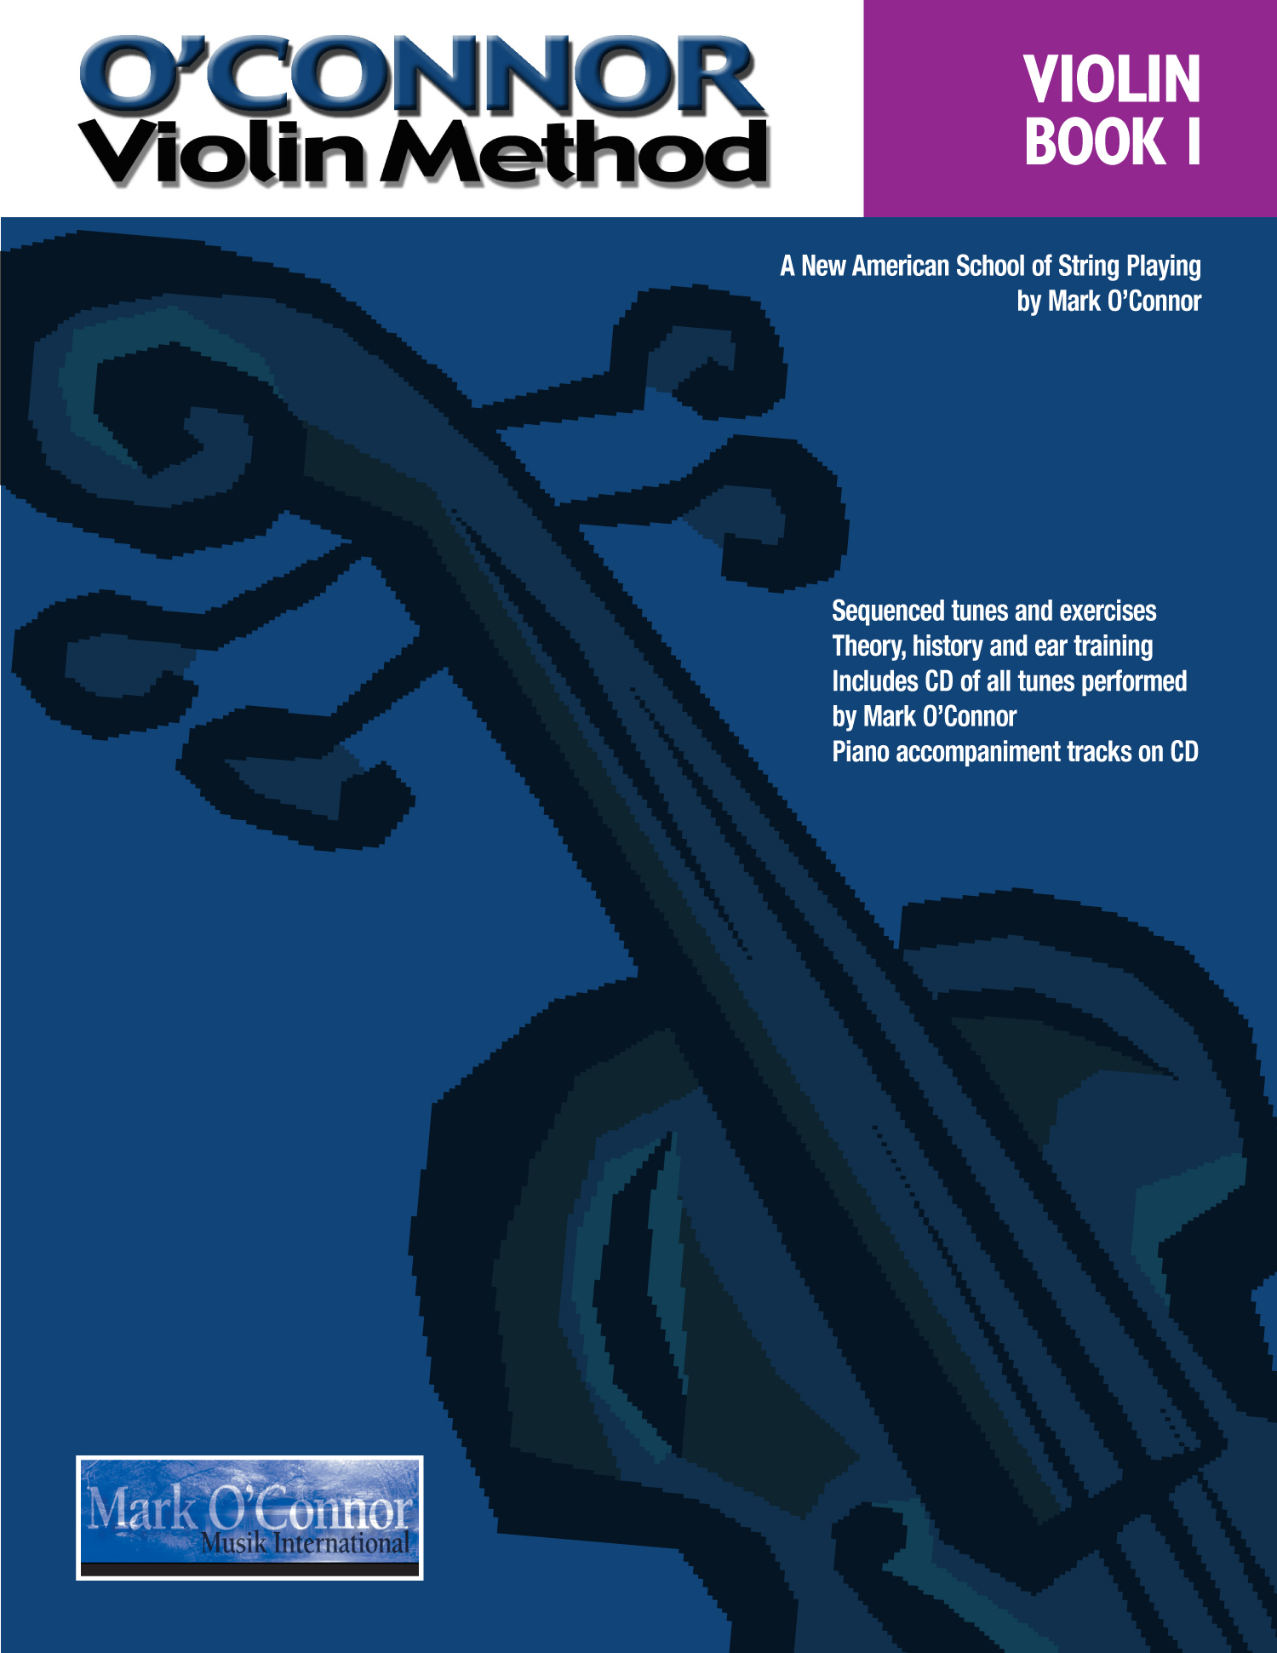

Esteemed *O’Connor Method* Faculty Members will instruct in Violin, Viola, Cello, Double Bass, Orchestra, and Teacher Training. Guitar and Mandolin electives available.

Find out more about the *O’Connor Method* at

**www.oconnormethod.com**

Contact us at

**info@oconnormethodcampnyc.com**

Register at

**www.oconnormethodcampnyc.com**

@oconnormethod

Mark O’Connor “O’Connor Method”

Directed by Mark and Maggie O’Connor

***"Thank you for assembling such kind, wonderful and talented people!"  
  
"talented, supportive, generous-spirited teaching artists!"   
  
"I marvel at the creativity, joy, & artistry pouring out of every room."  
  
“Thank you for caring and for giving so much to the music world, especially the world of string education."  
  
"I’m still singing all those amazing tunes. So many amazing moments."***

Orientation Jul. 30

Jul. 31 – Aug. 4, 2017

O’Connor Band in Residence